Test Sections
Multiple Choice: 30 points
15 questions at 2 points each
20 minutes

Sentence Revision 30 points
6 questions at 4 points each
15 minutes

Sentence Diagrams: 40 points
4 diagrams at 10 points each
30 minutes

Bonus Sentence Creation: 10 points
5 questions at 2 points each
10 minutes

Student Name

______________________________________________________________________________________
Section A: Multiple Choice
Question One: Which of these best describes the tense of the following sentence? (2 pts)
Sentence: My mother was happy until her divorce.
Answer:
- Present Tense
- Future Tense
- Past Tense
- No Tense (Modal)

Question Two: Which of these best describes the aspect of the following sentence? (2 pts)
Sentence: I will be improving my grammar steadily this semester.
Answer:_____
- Simple Aspect
- Progressive Aspect
- Perfect Progressive Aspect
- Perfect Aspect

Question Three: Which of these sentences is written in Present Perfect Progressive (Present Tense, Perfect Progressive Aspect)? (2 pts)
Answer:_____
- I have been throwing frisbees.
- I had been throwing frisbees
- I was throwing frisbees
- I have thrown frisbees.

Question Four: Which of these sentences is in simple present (Simple Aspect, Present Tense)? (2 pts)
Answer:_____
- I had a cake.
- I do like that cake.
- I was packed up.
- He has been sleepy.

Question Five: Which of these sentences is in passive voice? (2 pts)
Answer:_____
- My idea was very impressive.
- My idea had been impressing people.
- My idea was approved.
- My idea is bothering me.

Question Six: Which of these sentences is in active voice? (2 pts)
Answer:_____
- Bob has been by the sea all day.
- The proposal will be endorsed.
- Steven could have been thrown out a window.
- I was bothered by that last statement.

Question Seven: Which of these sentences correctly transforms the active voice sentence below into passive voice (while maintaining all other elements)? (2 pts)
Sentence: I certainly would have approved that decision.
Answer:_____
- That decision certainly would have been approved.
- That decision did get approved.
- That decision was approved.
- That decision certainly would be approved.

Question Eight: Which of these sentences correctly transforms the passive voice sentence below into active voice (while maintaining all other elements)? (2 pts)
Sentence: The building plan has been approved by the inspector.
Answer:_____
- The inspector has been approving the building plan.
- The inspector has approved the building plan.
- The inspector approved the building plan.
- The inspector had approved the building plan.

Question Nine: Which of these sentences correctly transforms the active voice sentence below into passive voice (while maintaining all other elements)? (2 pts)
Sentence: The dean has been awarding a medal of distinction to the most stellar students
Answer:_____
- A medal of distinction was awarded to the most stellar students by the dean.
- A medal of distinction has been being awarded to the most stellar students by the dean.
- The most stellar students were being awarded a metal of distinction by the dean.
- By the dean, the most stellar students have been awarded a metal of distinction.
Question Ten: Which of the sentences below does NOT include a modal? (2 pts)
Answer:_____
- I shall never falter.
- A can of beans is my favorite snack.
- I really could not say.
- This poem may be my magnum opus.

Question Eleven: Which of the sentences below does NOT include an auxiliary verb? (2 pts)
Answer:_____
- I do believe in ghosts.
- Poppies have put them to sleep.
- Dorothy has no ruby slippers.
- The witch will be getting crushed under a house.

Question Twelve: Which of the sentences below DOES include an auxiliary verb? (2 pts)
Answer:_____
- I never was so sorry.
- I did the best I could.
- My in-laws have several jet-skis in their garage.
- Sarah’s cookies were eaten by mistake.

Question Thirteen: Which of the sentences includes BOTH a modal AND an auxiliary verb? (2 pts)
Answer:_____
- I could have another bite.
- My sister’s casserole was great.
- We will be taking any leftovers home with us.
- My sister might be sad though.

Question Fourteen: Which of the sentences includes NEITHER a modal NOR an auxiliary verb? (2 pts)
Answer:_____
- I really have a problem.
- I did say something rude.
- I could be more careful next time.
- It will take time for you to forgive me.

Question Fifteen: Which of the sentences below does NOT include a modal? (2 pts)
Answer:_____
- I never have changed my will.
- I might know how to do the can-can
- I must be me.
- I shall study very hard.

Section B: Sentence Revision (30 pts)
Question Sixteen: (4 pts)
Revise this sentence by transforming it to Past Perfect (Past Tense, Perfect Aspect).
Sentence: I am afraid of ghosts.
I had been afraid of ghosts

Question Seventeen: (4 pts)
Revise this sentence by transforming it to Present Progressive (Present Tense, Progressive Aspect).
Sentence: I had communicated more clearly.
I am communicating more clearly.

Question Eighteen: (4 pts)
Revise this sentence by transforming it to Past Perfect Progressive.
Sentence: Derrick has played dominos all morning.
Derrick had been playing dominos all morning

Question Nineteen: (4 pts)
Revise this sentence to change the voice from Active to Passive. Maintain the original tense and aspect in the new sentence.
Sentence: Peter Sellers played several characters in A Mouse that Roared
In a Mouse that Roared, several characters were played by Peter Sellers.

Question Twenty: (4 pts)
Revise this sentence to change the voice from Passive to Active. Maintain the original tense and aspect in the new sentence.
Sentence: Trudy’s hair is being styled by Uncle Pedro.
Uncle Pedro is styling Trudy’s hair.

Question Twenty One: (4 pts)
Revise this sentence to change the voice from Active to Passive. Maintain the original tense and aspect in the new sentence.
Sentence: All last month, the lazy scientists could have been processing this new information.
All last month, this new information could have been being processed by the lazy scientists.

Section C: Sentence Diagrams: 40 points (4 diagrams, 10 points each)
Instructions: For each sentence below, take three steps
- Answer the questions below the sentence
- Draw a tree diagram as we have practiced in class.

I have provided five empty pages in the back of the exam if you need them. Please just clearly indicate which is your final answer!
Parts of Speech  - Noun = N  - Verb = V  - Adjective = Adj  - Adverb = Adv  - Determiner = Det  - Preposition = Prep  - Pronoun = Pro  - Interjection = Intj  - Conjunction = Conj  - Relativizer = Rel  - Complementizer = Comp  - Auxiliary = Aux  - Modal = Mod  Phrase Types  - Noun Phrase = NP  - Verb Phrase = VP  - Adjective Phrase = ADJP  - Adverb Phrase = ADVP  - Prepositional Phrase = PP  - MVP = Main Verb Phrase | Roles  - Subject = Subj  - Predicate = Pred  - Adverbial = Advl  - Subject Complement = SC  - Direct Object = DO  - Indirect Object = IO  - Object Complement = OC  Clauses  - Sentence = S  - Independent Clause = IC  - Dependent Clause = DC  - Relative Clause = RC  - Complement Clause = CC  Sentence Patterns  - Copular Be  - Linking Verb  - Intransitive  - Transitive  - Ditransitive with Direct Object and Indirect Object  - Ditransitive with Direct Object and Object Complement

Question Twenty Two: Please answer the questions below and then diagram this sentence. (10 pts)
Sentence: My aunt and her partner have gone to Santa Fe for years.
- What is the aspect of sentence
  - Simple, Perfect, Progressive, Perfect Progressive

- What is the tense of the sentence?
  - Past or Present
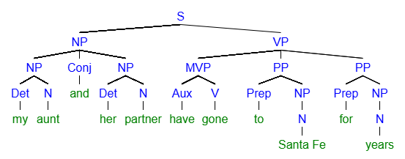
Question Twenty Three: Please diagram this sentence. (10 pts)
Sentence: When bad weather has been predicted, I always watch the news.
- What is the voice of the first clause (When bad weather has been predicted)?
  - Passive or Active

- What is the tense of the first clause (When bad weather has been predicted)
  - Past or Present

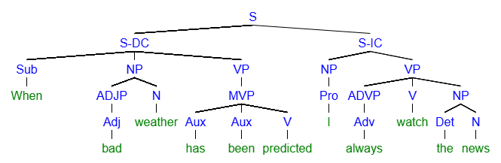
Question Twenty Four: Please answer the questions below and then diagram this sentence. (10 pts)
Sentence: After the meeting, many employees were given a promotion, and some were terminated.
- What is the voice of the second clause (some were terminated)
  - Active or Passive

- What is the aspect of the first clause (many employees were given a promotion)
  - Simple, Perfect, Progressive, or Perfect Progressive

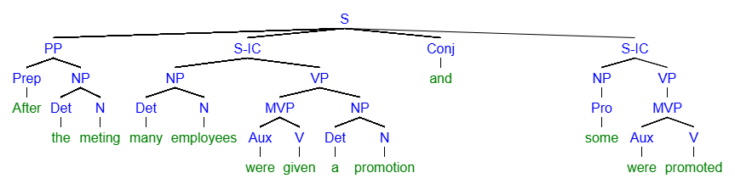
Question Twenty Five: Please answer the questions below and then diagram this sentence. (10 pts)
Sentence: Sentence: Gerlad could have been a millionaire but foolishly squandered his inheritance on trifles.
- What is the voice of the first verb phrase (could have been a millionaire)
  - Active or Passive

- What is the aspect of the verb phrase (could have been a millionaire)
  - Simple, Perfect, Progressive, or Perfect Progressive

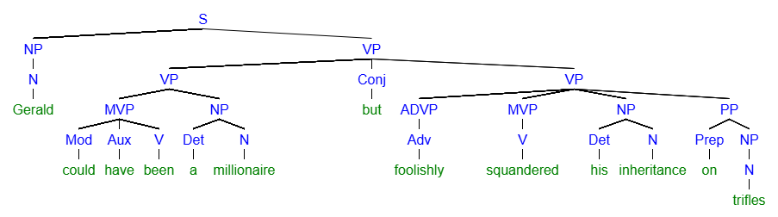
Section C: Bonus Sentence Creation (10 points)
For section C, please write all the new sentences about a movie, book, or TV show you like. Feel free to reuse the same ideas and characters from the movie, book, or TV show as many times as you like. Feel free to copy from/mirror your earlier sentences in this activity. Be sure to punctuate the sentences correctly!
Name the movie, book or TV show here:___________________

Bonus One: (2 points)
Write a sentence containing this element: coordinating conjunction connecting two clauses
- Oliver eats dips, and Mable isn’t picky.

Bonus Two: (2 points)
Write a sentence containing this element: a passive voice verb phrase in past tense
- Sephira’s saddle had been sat on by Aragon.

Bonuse Three: (2 points)
Write a sentence containing this element: a verb in past perfect progressive
- Lola Bunny had been throwing basketballs.

Bonus Four: (2 points)
Write a sentence containing this element: “Did” as an auxiliary verb
- Harry did fight.

Bonus Five: (2 points)
Write a sentence containing this element: Two VPs with different aspects (one aspect for VP one and a different aspect for VP two)
- Aragon was excited and had been looking forward to flying.

